## Getting Started

### 1. Generate the React Native Application

```bash

npx ignite-cli new MyReactNativeApp

2. Set Up the Environment

bash--

npm install

3. Install Maestro

cd MyReactNativeAppInstall WSL2 (Windows Subsystem for Linux) by running the following command in PowerShell as an administrator: wsl --install. Follow the instructions and restart your computer.

Install Java 11 by running the following command in the terminal: sudo apt install openjdk-11-jdk.

Install Maestro by running the following command in the terminal: curl -Ls "https://get.maestro.mobile.dev" | bash.

After completing these steps, you can check if Maestro is installed by running the command maestro --version. You can also run an Android emulator and write your first flow.

Write Maestro Tests

Write end-to-end tests using Maestro in the e2e directory.

bash

maestro test flow.yaml

Maestro Configuration

Create a maestro-config.js file in the project root:

module.exports = {

testDir: 'e2e',

android: {

binaryPath: 'android/app/build/outputs/apk/debug/app-debug.apk',

},

ios: {

binaryPath: 'ios/build/Build/Products/Debug-iphonesimulator/MyReactNative.app',

},

};

Defining the UI Test

# login.yaml

appId: com.example.app

---

- launchApp

- tapOn: "Email"

- inputText: "utkarsha@example.com"

- tapOn: "Password"

- inputText: "Secret@123"

- tapOn: "Login"

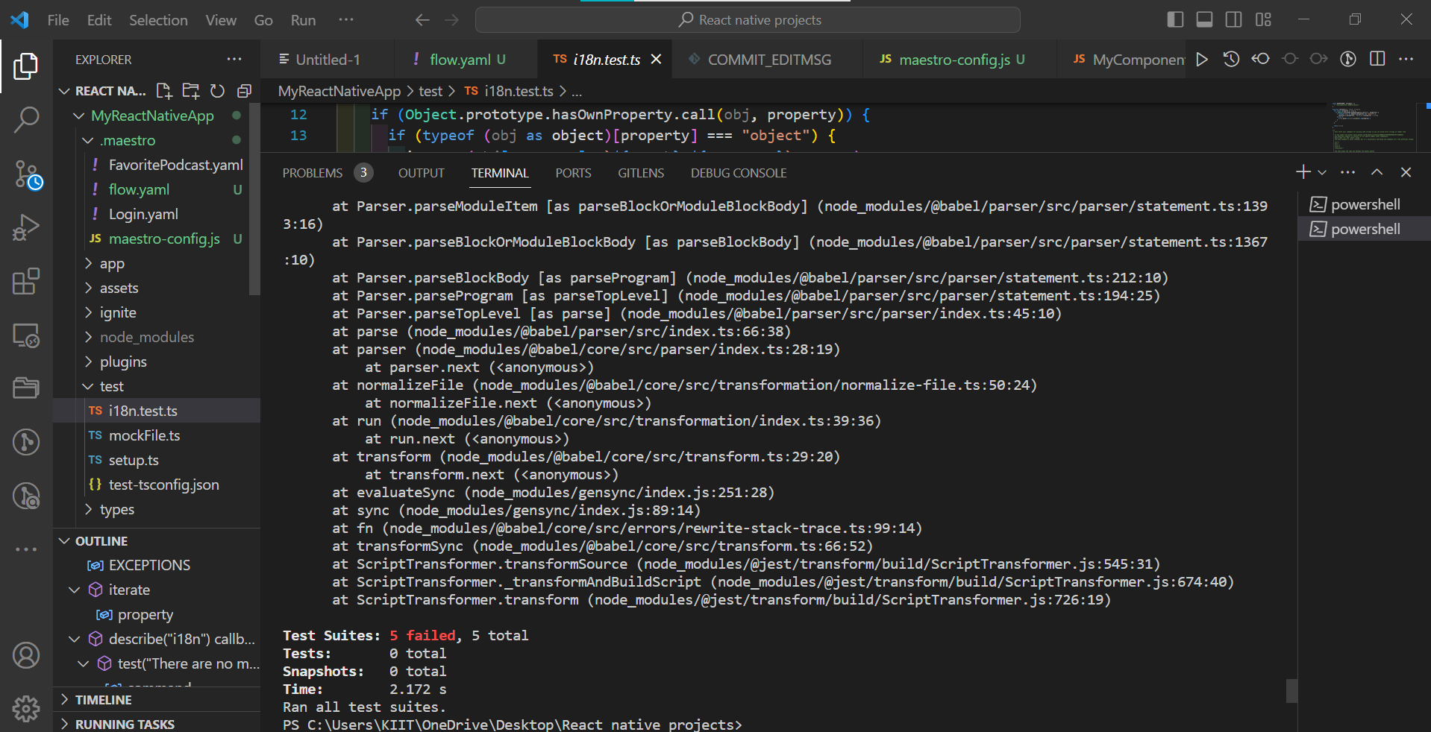

Code Report

Generate a code report for your test results.

README.md

Include detailed documentation in the README.md file. Document each step taken from setting up the environment to writing tests. Include screenshots or code snippets where necessary.

Push Code to GitHub

Create a new repository on GitHub.

Commit your project, including the application, test codes, reports, and documentation.

bash

Copy code

git init

git add .

git commit -m "Initial commit"

git remote add origin https://github.com/your-username/MyReactNativeApp.git

git push -u origin masterhttps://github.com/Harshitanand11/MyReactNativeApp/tree/initial-commit

these are the screenshot for future reference

